**Name: Ahmed Essam Ibrahim Abdellah**

**B.N: 94**

**Date:**

**Topic:** **Artificial intelligence**

**Github link:**

**Github page:**

**Application brief:**

For quite a long time now the value of artificial intelligence and its subsequent components are recognized. They are used as tools and strategies for making this planet a safer place. And just not wanting to go to all expensive computer tools to have them. You should easily look around and I'm pretty much confident that the use of artificial intelligence makes most of the tasks simple.

Its importance lies in simplifying our lives. These systems are a great benefit to humanity, and are thus designed to reduce as much as possible human action. They prefer to have the ability to work in an automated fashion and consequently manual intervention is the least that could be requested or seen while trying to operate pieces associated with this technology.

These machines help speed up your processes and tasks along with a guaranteed level of accuracy and precision and therefore this is what makes them an important and useful tool. Such innovations and software are not only relevant to our general and daily lives, while making the world an error-free environment through their simple and practical techniques. It also impacts and also has importance for other realms.

**Screenshots:**

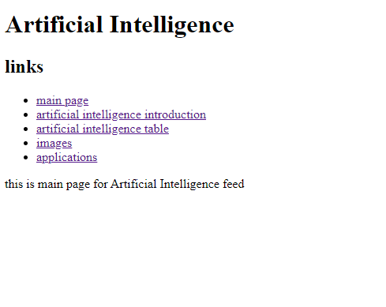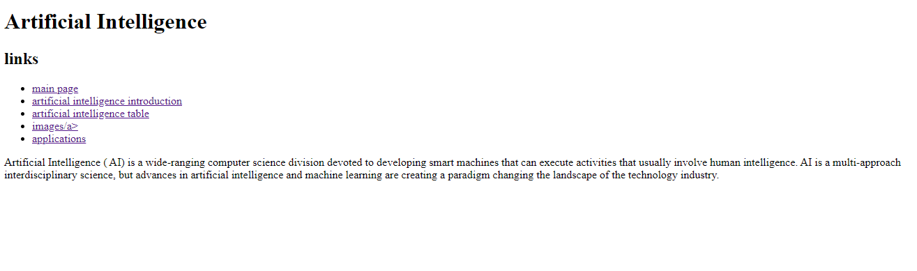

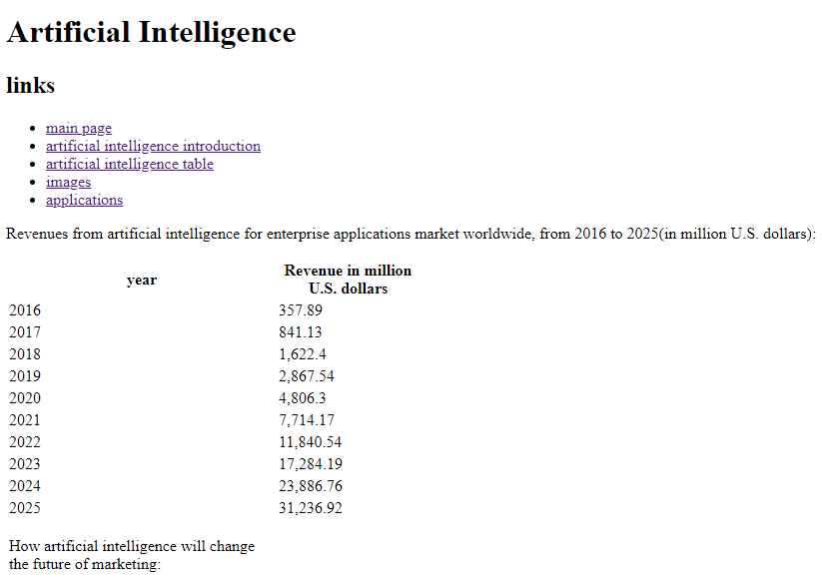

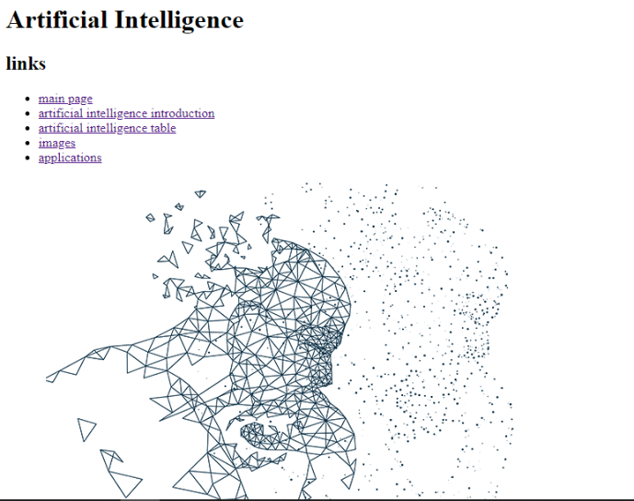 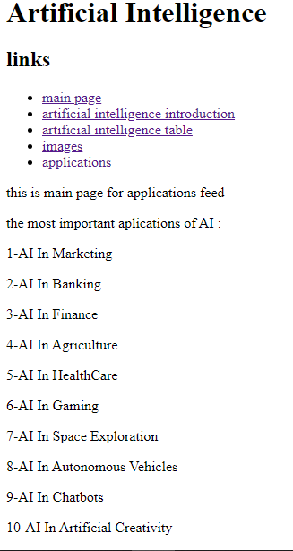

**Source code:** 